**JAYPEE INSTITUTE OF INFORMATION TECHNOLOGY**

# Work Summary Sheet

**Project Title-:**

**QUALITATIVE ASSESSMENT OF EXAMINATION QUESTIONS WITH BLOOM’S TAXONOMY**

Dhruv Taneja (B9) (20103269)

Tanupriya Pathak (B10) (20103288)

Palak Singh (B9) (20103270)

## Motivation behind the project

The education is moving with a fast speed and in Order to keep up ourselves with the pace of the education we tend to ignore the workload that teachers face in order to classify a question paper. Teachers already have a lot of pressure including, a whole semester plan, making ppt of the modules, thus the pressure of classifying the question paper in the which level they lie is massive and sometimes teacher face burden and pressure to complete the work.

Our project aims to easily classify questions provided by teachers into Bloom’s taxonomy levels. This will not just help teachers but can also help student and can help in decreasing the pressure and mismanagement caused in the education system.

**Type of project:**

* Research cum Development project

**Major Research Papers Consulted:**

[1] Goh, T. T., Mohamed, H., Jamaludin, N. A. A., Ismail, M. N., & Chua, H.

S. (2020). Questions Classification According to Bloom’s Taxonomy using

Universal Dependency and Word Net. Test Engineering and Management, 82,

4374-4385.

[2] Omar, N., Haris, S. S., Hassan, R., Arshad, H., Rahmat, M., Zainal, N. F.

A., & Zulkifli, R. (2012). Automated analysis of exam questions according to

Bloom's taxonomy. Procedia-Social and Behavioral Sciences, 59, 297-303.

[3] Wankhede, H. S., & Kiwelekar, A. W. (2016). Qualitative assessment of

software engineering examination questions with bloom’s taxonomy. Indian

Journal of Science and Technology, 9(6), 1-7.

# [4] Question classification based on Bloom’s taxonomy cognitive domain using modified TF-IDF and word2vec-NCBI

# [5] Text Classification with BERT in PyTorch

**Overall design of project:**

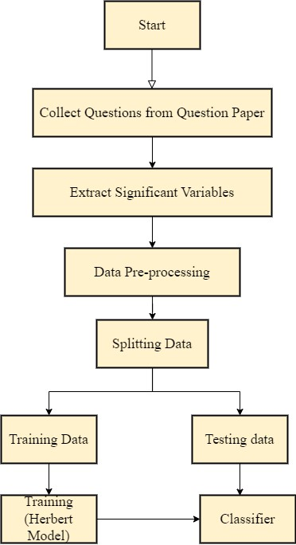

**FEATURES BUILD AND LANGUAGES USED:**

**We have used the bert model and have combined two dataset to make our classification more accurate and correct. We have used many inbuilt libraries such as:**

**Model:**

**Numpy, Pandas, Transformers, TensorFlow, Tqdm**

**Website:**

**PYTHON, DJANGO, HTML, CSS, JAVASCRIPT**

**PROPOSED METHODOLOGY:**

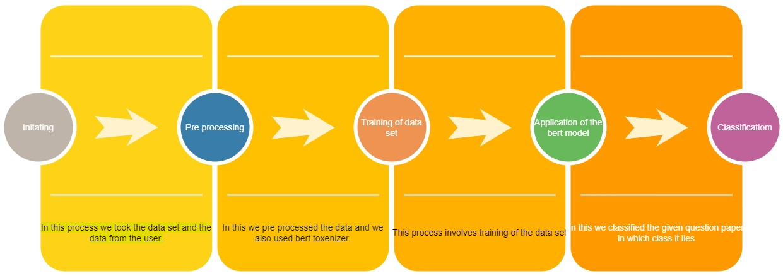

**Algorithm/Description of the Work:**

* ML Model: Bert using TensorFlow
* Educa Website (Frontend): HTML, CSS, JavaScript
* Educa Website (Backend): Django

**Division Of Work:**

**TANUPRIYA PATHAK 33.3%**

**PALAK SINGH 33.3%**

**DHRUV TANEJA 33.3%**

# Result:

* 83% accuracy of model
* Prediction is being carried out successfully